March, 2021

1. Induction Programme For The Students Of M.Com And M.A Economics 1st Semester

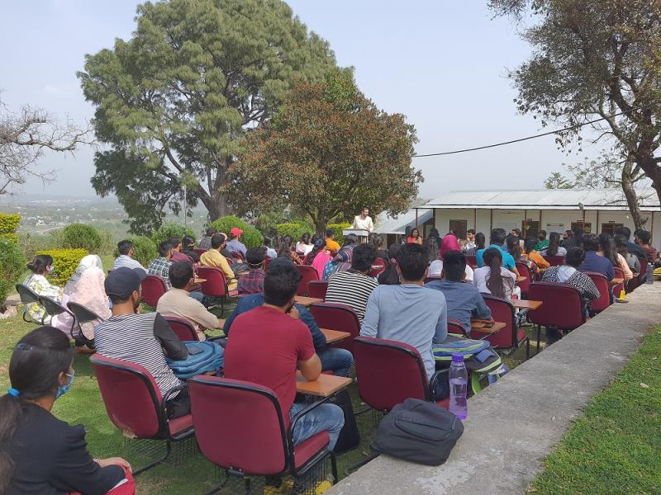

2. Lecture On Financial Awareness Organized By Udhampur Campus, University Of Jammu In Collaboration With University Of Jammu Special Purpose Vehicle Foundation (UOJSPVF) Under Udhampur Campus Community Facilitation Centre (UCCFC)
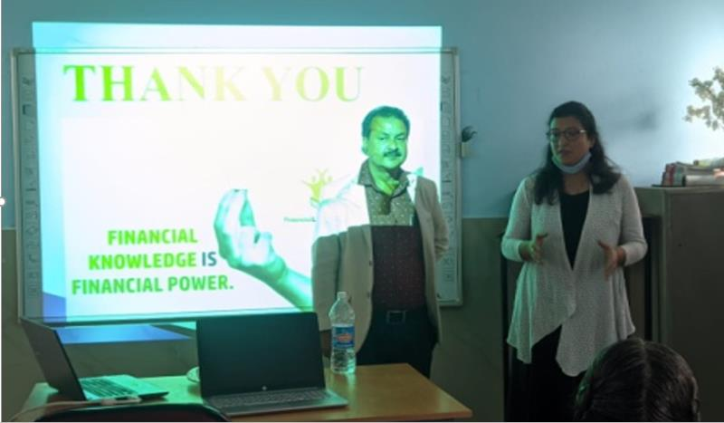
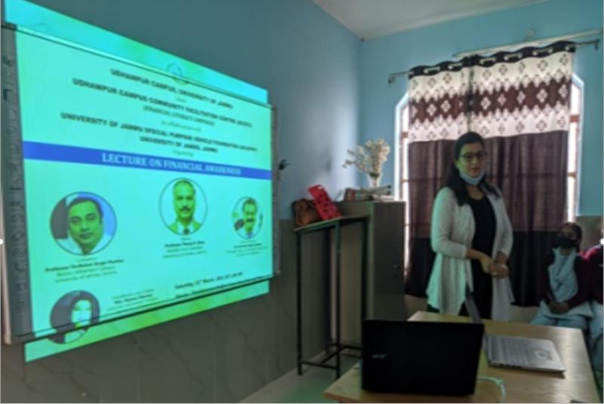

3. ONLINE WEBINAR ON “INNOVATIVE PEDAGOGICAL METHODOLOGIES AND TOOLS FOR EFFECTIVE LEARNING IN SCIENCE, SOCIAL SCIENCE- HUMANITIES, COMMERCE AND MANAGEMENT EDUCATION” ORGANISED BY UDHAMPUR CAMPUS, UNIVERSITY OF JAMMU UNDER UDHAMPUR CAMPUS CAPACITY BUILDING SERIES (UCCBS) IN COLLABORATION WITH UNIVERSITY BUSINESS INCUBATION AND INNOVATION CENTRE
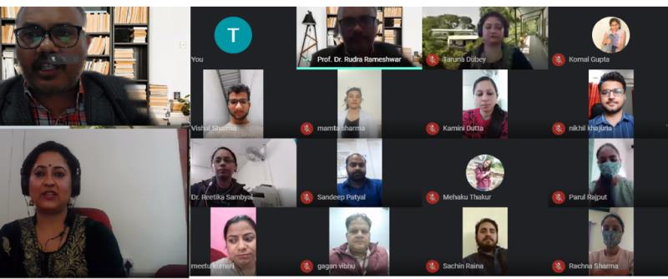

4. Inauguration Of “Skill Development Certificate Programme For Stitching, Knitting And Embroidery” In Collaboration With University Of Jammu Special Purpose Vehicle Foundation (UOJSPVF) Under Udhampur Campus Community Facilitation Centre (UCCFC) On The Eve Of “INTERNATIONAL WOMEN DAY”

