ONLINE WEBINAR ON “INTRODUCTION TO INDIAN SECURITIES MARKET” ORGANISED BY UDHAMPUR CAMPUS IN COLLABORATION WITH SEBI AND NSDL UNDER UDHAMPUR CAMPUS CAPACITY BUILDING SERIES (UCCBS)

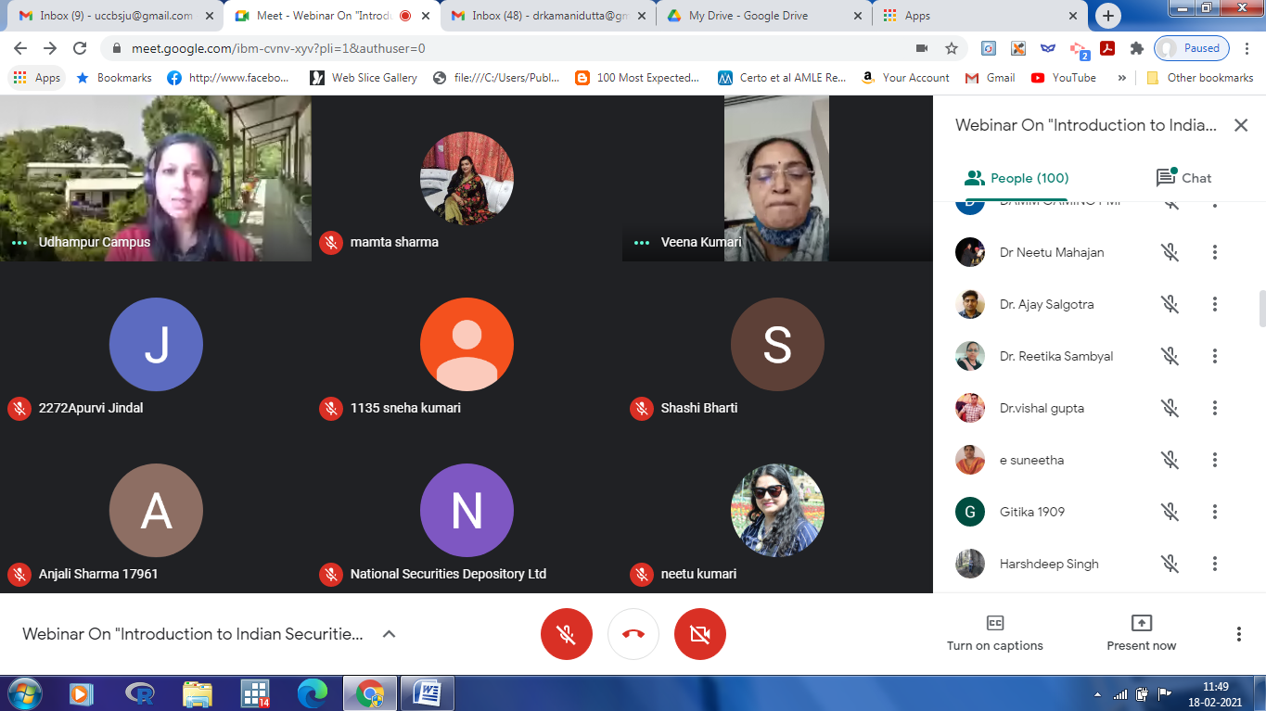

Udhampur Campus, University of Jammu organized a National Webinar on the topic “Introduction to Indian securities market on 18th feburary , 2021, under the Rectorship of Professor Parikshat Singh Manhas.

There were 306 registrations for the webinar from various colleges and universities of different parts of the country.
The webinar began with an introduction by Dr. Kamani Dutta, lecturer, Department of Commerce, Udhampur Campus University of Jammu. Dr. Dutta welcomed the participants and gave an overview of the webinar. The webinar was co-hosted with the Securities & Exchange Board of India (SEBI), and National Securities Depository Limited (NSDL), the apex Indian financial regulators and institutions. Udhampur campus is working in conjunction with apex institutions to bring updated and industry knowledge to the world. The Udhampur Campus Capacity Building Series will hopefully be a stepping stone in the enhancement of knowledge and skill of those working in the field of education
The eminent resource persons included Mrs. Venna Kumari (Senior manager at SEBI) and Mr. Aditya Bhoyte (Manager at NSDL).

The webinar was organized in two sessions. The first session was on the Securities Market where Mrs.Veena Kumari spoke about financial regulators’ role and shared her advice on how investors can protect their hard-earned money by only dealing with SEBI recognized entities when it comes to investment-related matters. She focussed on the measures taken by SEBI to enhance the efficency of the Indian capital market. She also mentioned about the online grievance redressal mechanism set up by SEBI, named as, SCORES (SEBI Complaints Redressal System) during the COVID-19 crisis.

Second session highlighted about depositaries where, Mr. Aditya Bhoyte stressed upon the need to have more self-regulated and systematic saving habits to secure one’s financial future. He also elaborated on various financial instruments to choose from and suggested a time-tested method to choose investment instruments wisely. He focused his presentation on how to start investing in the capital market by explaining the features and benefits of Demat Account and services of Depository Participants. Mr Bhoyte presented several important instructions on how to be a prudent investor.

There were several questions from participants and all questions were put forward to the speakers for discussion. The speakers answered all the questions very effectively. The question and answer session was hosted by Mr. Sandeep Verma (Assistant manager at NSDL).

Dr. Dutta proposed the vote of thanks. The participants provided very positive and motivating feedback about the webinar. She thanked Professor Parikshat Singh Manhas, Rector, Udhampur Campus, University of Jammu for giving permission to organise this webinar and inviting eminent speakers to conduct it .Special thanks to Prof. Manoj Kumar Dhar, Hon'ble Vice-Chancellor, University of Jammu, patron of the webinar for his continuous support and guidance. The teaching faculty present during the event included Mr. Nikhil Khajuria,Dr. Ajay Salgotra. Dr. Neetu Kumari, Dr. Ritika Sambyal, Mrs. Mamta Sharma, Mrs. Taruna Dubey, Mrs. Shilpa Gupta and Mr. Vinod Kumar.

