Online Webinar on Deconstruction of an advertisement Organized By Udhampur Campus, University Of Jammu In Collaboration With University of Jammu Special purpose Vehicle Foundation Under Udhampur Campus Capacity Building Series (UCCBS)

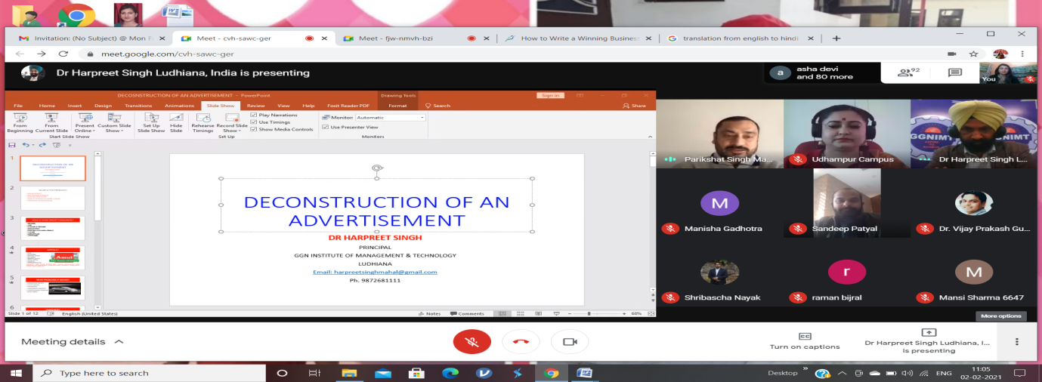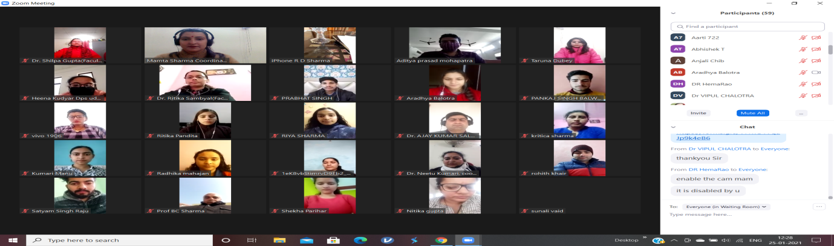
Udhampur Campus, University of Jammu Organised webinar in collaboration with University of Jammu Special purpose Vehicle Foundation under Udhampur Campus Capacity Building Series (UCCBS) on the topic “Deconstruction of an advertisement” on 2nd February, 2021 under the Rectorship of Professor Parikshat Singh Manhas. Dr. Neetu Kumari (Co-ordinator, Department of Commerce), webinar coordinator while giving the brief introduction about the webinar she addressed the audience that it is a very proud moment for the Udhampur Campus to organise such event that provides a platform for intellectual growth inspite of maintaining social distancing which is the new norm. Webinars are not only a need of the hour but also had become an inevitable platform that brings intellectuals from various parts of the country together during this present pandemic scenario. 2019 had been a tough year following covid-19 pandemic which brought a halt to almost every activity and education sector was one amongst them. It was realised that learning and sharing of knowledge couldn’t be stopped. Webinar is a great way to manage our professional activities while maintaining social distancing. Although webinars are not a new discovery but there is a definite increase in their use and even the faculty of Udhampur Campus brought it into use for sharing the knowledge and reaching out to the audience at large through Udhampur Campus Capacity Building Series (UCCBS).
While welcoming resource person Dr. Harpreet Singh, Principal, GGN institute of management and technology, Ludhiana and delegates in the webinar Professor Parikshat Singh Manhas, Rector Udhampur Campus (webinar convenor) addressed the audience that it is a very proud moment for the Udhampur Campus to organise such event, which is not only the need of the hour but has become a necessary activity in between tough pandemic time. He also ensures that Udhampur Campus will continue to conduct such activities in the near future. He also ensures to conduct a workshop in upcoming time. He also congratulate the UCCBS team for organising such an event.
Dr. Harpreet Singh started the webinar with introduction about the topic and said that participants will receive and learn theoretical knowledge. At the same time, employability potential is possible though analytical Skills. Every business management, be it of Marketing or Finance specialization, needs to develop these skills. Function of Marketing is incomplete if we cannot find and communicate with our prospective consumer. An advert is always contagious if it has been constructed well. The reverse of it i.e. Deconstruction of an advert helps a student of business management to learn the skills of managing business communications effectively. One example of Deconstruction is enough to understand business skills, if done properly. This webinar will help to focus on the same. The webinar will be mix of infotainment. Entrepreneurs, Businessman, Students and teachers who are participating in the Seminar will understand that advertising is highly specialized craft. It will also help Entrepreneurs and Businessman to make attractive advertisement.
There were 223 registrations for the webinar from various colleges and universities from the different parts of the country. Dr. Neetu Kumari, webinar coordinator presented a vote of thanks. She thanked Professor Parikshat Singh Manhas, Rector, Udhampur Campus, University of Jammu who guided and supported to take an initiative to start Udhampur Campus Capacity Building Series (UCCBS) . Special thanks to the Prof. Manoj Kumar Dhar, honb’le Vice Chancellor, University of Jammu, patron of the webinar for his continuous support and guidance .
Teaching faculty present during the event included Mrs. Mamta Sharma, Mrs. Taruna Dubey, Mr. Vinod Kumar, Dr. Ritika Sambyal, Dr. Kamani Dutta, Dr. Shilpa Gupta, Mr. Nikhil Khajuria and Dr. Ajay Salgotra.

