Inaugration of Udhampur Campus Community Facilitation Centre (UCCFC), Financial Literacy Campaign Organized by Udhampur Campus, University Of Jammu In Collaboration With University of Jammu Special Purpose Vehicle Foundation(UOJSPVF)

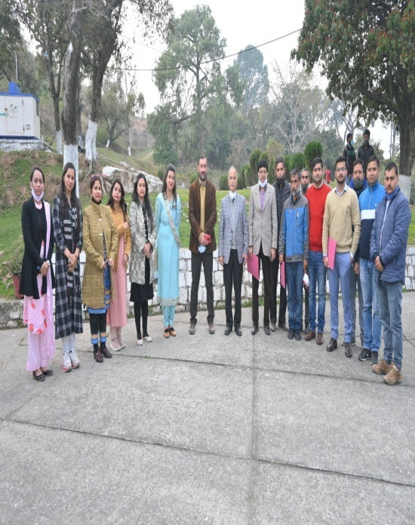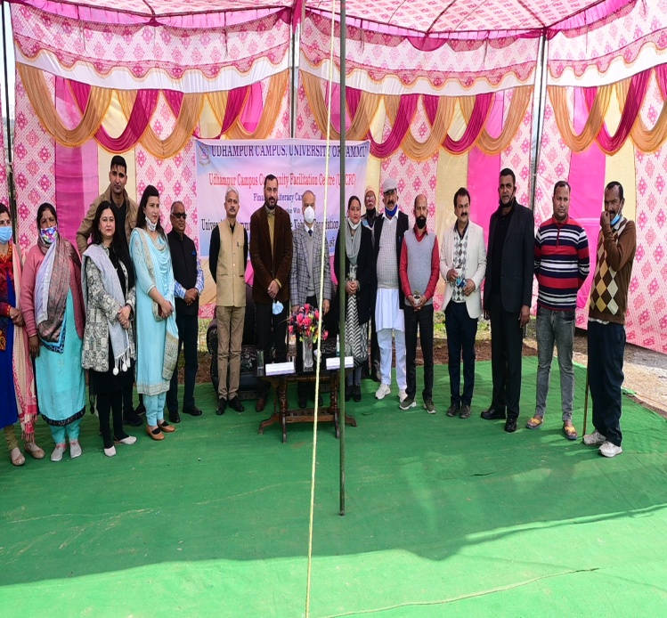

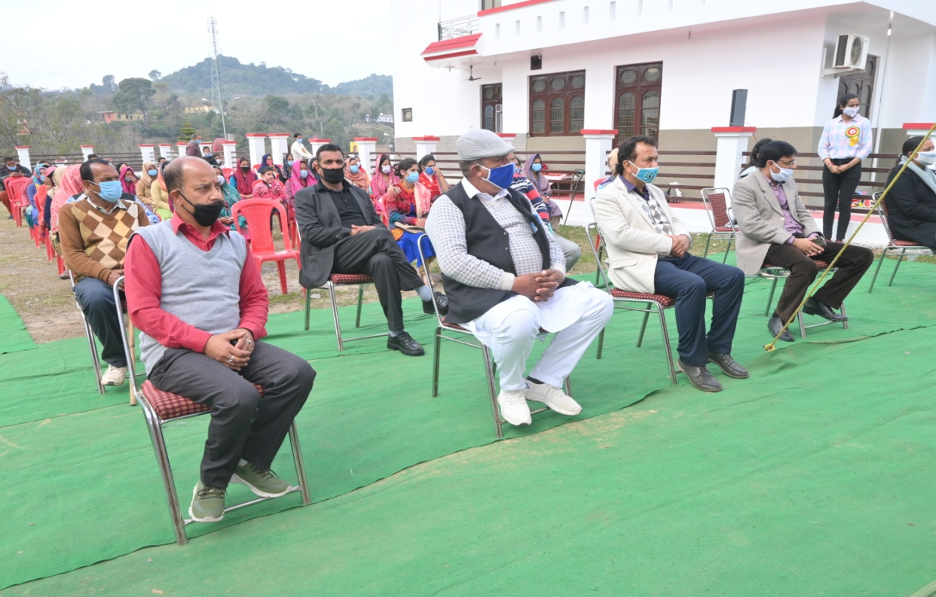

Udhampur Campus, University of Jammu inaugurated Udhampur Campus Community Facilitation Centre (UCCFC) in Collaboration with University of Jammu Special purpose Vehicle Foundation (UOJSP) under the rectorship of Professor Parikshat Singh Manhas, Udhampur Campus, University of Jammu.
The Chief Guest of the event was Professor Manoj K. Dhar, Vice Chancellor, University of Jammu, Professor Parikshat Singh Manhas, Rector, Udhampur Campus was guest of the honour and other dignitaries presented in the event were Mrs Nisha Sharma (BDC), Mr. Sanjeev Kumar Gupta (Branch Head, J&K Bank Tikri), Mr Romesh Singh Salathia Principal Government Higher Secondary School Mr Yash Paul Sharma (Sarpanch, Tikri), Captain Arjun Singh (Sarpanch, mand West),.
Ms. Mamta Sharma Lecturer Commerce department, Udhampur Campus and coordinator of the event, while giving the brief introduction about the inaugural function of the UCCFC said that it provides a platform for community to get awareness about the financial literacy. She said that financial literacy is the education and understanding of various financial areas including topics related to managing personal finance, money, borrowing, and investing.
Professor Parikshat Singh Manhas, Rector Udhampur Campus at the onset welcome Professor Manoj K. Dhar, Vice Chancellor, University of Jammu and other distinguished guests. He addressed the audience that it is a very proud moment for the Udhampur Campus to organise such events that is the need of the hour. He also ensured that Udhampur Campus will continue to conduct such activities in the near future under UCCFS and UCCBS. He made sure to come up with more Community Building Programs in future. Udhampur Campus has taken various initiatives on regular basis to start the various series in the Udhampur Campus via both online and offline mode. Today Udhampur Campus had added one more step through the inaugural ceremony of Udhampur Campus Community Facilitation Centre with the aim to serve the common people and nation.
Beside above mentioned events, various Village Development Programs had been organised by Udhampur Campus including Swachh Bharat Mission, personal hygiene program, awareness program for their upliftment. Faculty and Students of Udhampur made door to door visit in the villages for spreading awareness under N.S.S and plantation drive was organised under the mission of green and clean campus. Udhampur Campus is also providing the best opportunities to the students of the campus for empowering them to make their future bright.
Hon’ble Vice Chancellor, Professor Manoj K. Dhar, University of Jammu who was the chief guest on the occasion appreciated the unique efforts of Udhampur Campus, for taking an initiative to start Udhampur Campus Community Facilitation Centre (UCCFC). In his presidential remarks he said that organizing such programs is our social responsibility to develop our community. Hon’ble Vice Chancellor thanks to the lieutenant governor to start section 8 company in the university of Jammu and to take various initiative that will assist in the advancement and upliftment of the unemployed people. He congratulated Professor Parikshat Singh Manhas, Rector Udhampur Campus for his efforts and also assured to the people that he will introduce more courses and skill based programs in Udhampur Campus. So that their kids can get higher education in the near by campus. He also assured principal of Govt. Hr. Sec. School to introduce training program of mushroom cultivation from their school. Through his word of motivation he inspired the women and girls of the villages to take a step for their empowerment.
Mrs. Nisha Sharma (BDC), Chairperson also shared her remarkable words. She explained that financial literacy is essential because it empowers people to make informed decisions about their money that fit the circumstances of their lives. However, this is an area where we can do better and also promised to organise the various programs for the upliftment of women and vulnerable groups.

Mr Sanjeev Kumar Gupta (Branch Head, J&K Bank Tikri) said that financial literacy is understanding the topic of money. Financial literacy represents one area of financial wellness. However, it takes more than financial literacy to make a meaningful difference in people’s lives. It takes a focus on behaviors, systems, sentiment, and making regular adjustments based on outcomes. Financial literacy helps improve a person’s confidence, sentiment and may help them make better decisions. However, financial literacy alone does not guarantee financial security. That is the way the NFEC’s focus is on all aspects of a person’s financials literacy through organising various community awareness programs. He also make the people aware hoe tp protect themselves from the digital frauds.
Mr Romesh Singh Salathia, Principal Government Higher Secondary School Tikri said that lack of financial literacy is a problem not only in emerging or developing economies. Consumers in developed or advanced economies also fail to demonstrate a strong grasp of financial principles in order to understand and negotiate the financial landscape, manage financial risks effectively, and avoid financial pitfalls. Principal sir also invited vice chancellor University of Jammu to organsie the upcoming events in their school to have an interaction with the students. He also made awared about requirements of the student to make their career bright. He said that there is need to inculcate the saving habits among the youth of the country.
There were around 100 people presented in the inaugural ceremony and followed all the SOPs. Dr Neetu Kumari, coordinator Department of Commerce presented a vote of Thanks. She thanked chief guest Professor Manoj Dhar (Vice Chancellor, University of Jammu) who spared their valuable time for being part of this program. She thanked all the dignitaries who spared their valuable time for being part of this occasion and special tanks to the Professor Parikshat Singh Manhas, rector, Udhampur Campus who guided and supported to take an initiative to start such events that are very useful not only from academic point of view but also from social point of view.

After the inauguration of UCCFC vice chancellor also visited Udhampur Campus have a round of the university premises and also have an interaction with the faculty members and assured that they will do all the needful to make the Udhampur Campus a vibrant and frontline campus.

