Online Webinar Organized By Udhampur Campus, University Of Jammu In Collaboration With University Business Incubation And Innovation Centre Under Udhampur Campus Capacity Building Series (UCCBS)
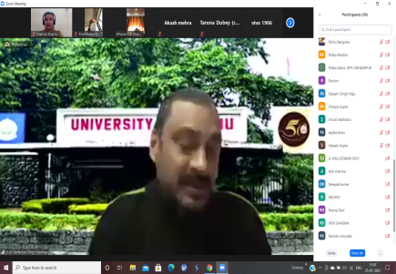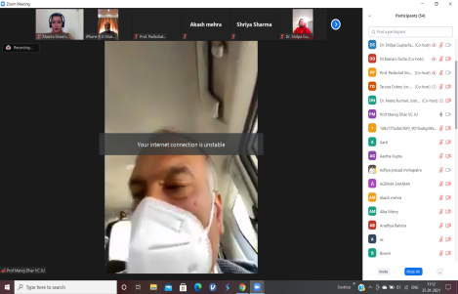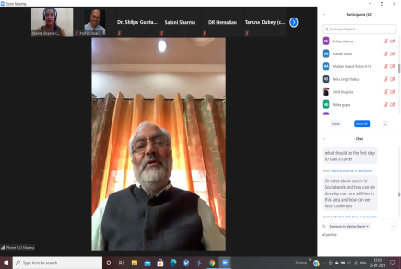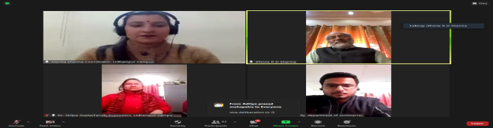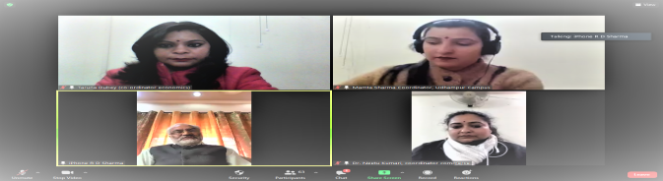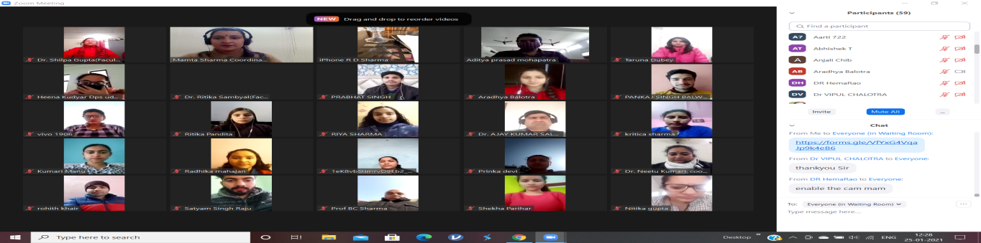

The Udhampur Campus, University of Jammu Organised webinar in collaboration with University Business Incubation and Innovation Centre under Udhampur Campus Capacity Building Series (UCCBS) on the topic “Dynamics of Career planning” on 25th January 2021 under the rectorship of Professor Parikshat Singh Manhas. Ms. Mamta Sharma (Lecturer in Commerce), webinar coordinator while giving the brief introduction about the webinar focused that planning one’s career, success and personal satisfaction often take top priorities. But it is important to achieve a positive and fulfilling career. Career planning and visioning is less about a rigid plan and more about having the tools one needs for the journey of navigating a career.
While welcoming Professor Manoj K. Dhar, Vice Chancellor, University of Jammu and Prof.(Dr.) R.D Sharma (Former VC, University of Jammu) in the webinar Professor Parikshat Singh Manhas, Rector Udhampur Campus (webinar convenor) said that it is a very proud moment for the Udhampur Campus to organise such an innovative international event on career planning which is not only a need of the hour but also had become an hot issue in the present pandemic scenario. He further assure the students as well as teaching faculty that this is only the beginning, in the coming days such events will be in the routine affairs of the Udhampur Campus and we all have to work enthuastically to make the Udhampur Campus a symbol of skill oriented, career developing and personality building educational hub. He further elaborated about the program to be conducted till the month of February.
Appreciating the unique effort of Udhampur Campus, on taking an initiative to start “Udhampur Campus Capacity Building Series”, Professor Manoj K. Dhar, Vice Chancellor, University of Jammu who was also the chief guest/Patron on the occasion in his presidential remarks said that the pace in which the world scenario is changing due to technological advancement and digitalisation, the traditional and conventional career opportunities are shrinking, so the educational institutions have also to rethink and plan accordingly to meet the challenges in the field of career planning.
Dr. R.D Sharma (Former VC, University of Jammu) was the resource person of the webinar. He started the webinar with his remarkable words said Career planning refers to the strategy a person uses to determine career goals and the path to achieve those goals. The process integrates various activities, including steps for self-improvement and the process of meeting these goals. During the session he have explained participants how to set a career vision, how to discover what matters in career, he defined factors for a successful career, He made student familiar with defining goals and needs, development of a personal career plan and discovering what’s nest in the career and challenges of academic growth in global era.
The importance of career planning can’t be overemphasized. Having a career plan is crucial for every person aspiring to become successful in life. It is a multi-stage process that needs to be thoroughly planned and executed to reap the desired benefits.
There were 230 registrations for the webinar from various colleges and universities from the different state of India. It is pertinent to mention that there was registration from other countries as well. Mrs Mamta Sharma, webinar coordinator presented a vote of thanks. She thanked all the dignitaries chief guest Profesoor Manoj Dhar (Vice Chancellor University of Jammu) and resource person Prof. (Dr.) R. D Sharma (Former Vice chancellor University of Jammu) who spared their valuable time for being part of this webinar and special thanks to the Professor Parikshat Singh Manhas, Rector, Udhampur Campus, University of Jammu who guided and supported to take an initiative to start Udhampur Campus Capacity Building Series (UCCBS).
All the teaching faculty was present during the webinar including Dr. Neetu Kumari, Ms. Mamta Sharma, Ms. Taruna Dubey. Dr. Shilpa Gupta, Dr. Kamini Datta, Dr. Ritika Sambyal, Mr. Nikhil Khajuria, Dr. Ajay Salgotra and Mr. Vinod Kumar.

