ONLINE WEBINAR ON

“INNOVATIVE PEDAGOGICAL METHODOLOGIES AND TOOLS FOR EFFECTIVE LEARNING IN SCIENCE, SOCIAL SCIENCE- HUMANITIES, COMMERCE AND MANAGEMENT EDUCATION”

ORGANISED BY

UDHAMPUR CAMPUS, UNIVERSITY OF JAMMU

UNDER UDHAMPUR CAMPUS CAPACITY BUILDING SERIES (UCCBS)

IN

COLLABORATION WITH UNIVERSITY BUSINESS INCUBATION AND INNOVATION CENTRE

PRESS RELEASE

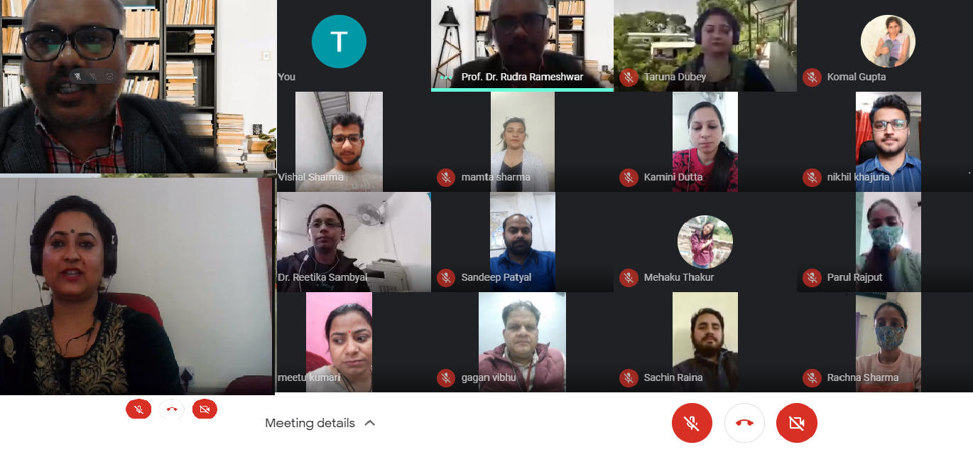
Udhampur Campus, University of Jammu organized a National Webinar on the topic “Innovative Pedagogical Methodologies and tools for effective learning in science, social science- humanities, commerce and management education’ on 10th March, 2021, under the Rectorship of Professor Parikshat Singh Manhas who is determined to impart knowledge and learning in innovative style. There were 86 participants for the webinar from various colleges and universities of different parts of the country.
The webinar began with an introduction by Dr. Neetu Kumari, co-ordinator, Department of Commerce, Udhampur Campus University of Jammu. Dr. Neetu welcomed the participants and gave an overview of the webinar whose main objective was to discuss about recent and innovative trends pedagogies in the field of education. She emphasised that the webinar is sought to determine the impact of use of improvised instructional materials on students and ability to link classroom content to improvised materials.
Dr. Rudra Rameshwar, an eminent professor from Thapar Institute of Engineering and Technology (Deemed to be University), Patiala, Punjab, India was the resource person for the webinar who spoke about the use of innovative methods in educational institutions not only to improve the level of education but also to empower people, strengthen governance and galvanize the efforts to achieve human development goal for the country. During the webinar he also explained various innovative methodologies and tools for effective learning like cognitive teaching, hybrid teaching, effective teaching, etc. Dr. Rameshwar also stressed upon different learning styles like auditory learner, visual learner, tactile learner, etc. He also discussed about meta-cognitive strategies, cognitive strategies and social strategies of learning. The webinar concluded with question answer session where the participants asked various questions that were effectively taken up by the resource person .
Dr. Neetu Kumari, webinar coordinator presented a vote of thanks. She thanked Professor Parikshat Singh Manhas, Rector, Udhampur Campus, University of Jammu who guided and supported to take an initiative to start Udhampur Campus Capacity Building Series (UCCBS). Special thanks to Prof. Manoj Kumar Dhar, Honb’le Vice Chancellor, University of Jammu, patron of the webinar for his continuous support and guidance .Teaching faculty present during the event included Mrs. Mamta Sharma, Mrs. Taruna Dubey, Mr. Vinod Kumar, Dr. Ritika Sambyal, Dr. Kamani Dutta, Dr. Shilpa Gupta, Mr. Nikhil Khajuria and Dr. Ajay Salgotra.

