Inauguration Of “Skill Development Certificate Programme For Stitching, Knitting And Embroidery” In Collaboration With University Of Jammu Special Purpose Vehicle Foundation (UOJSPVF) Under Udhampur Campus Community Facilitation Centre (UCCFC) On The Eve Of “INTERNATIONAL WOMEN DAY”

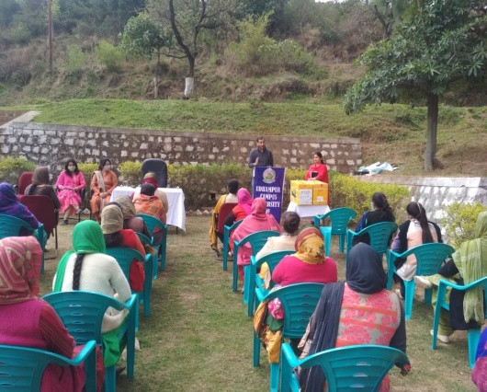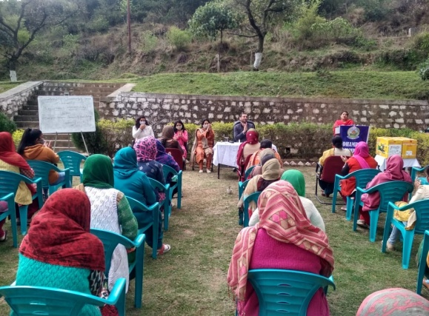

Udhampur Campus, University of Jammu celebrated “International Women Day” on 8th March 2021. Dr. Shilpa Gupta Lecturer, Economics Department, Udhampur Campus and Coordinator of the event, welcomed and congratulated all the ladies on this occasion. After this she gave the introduction about the “Skill Development Certificate Programme for Stitching, Knitting and Embroidery” that will be initiated soon under Udhampur Campus Community Facilitation Centre (UCCFC) in Collaboration with University of Jammu Special Purpose Vehicle Foundation (UOJSP).
The Chief Guest of the event was Smt.Bimla Kumari, Panch Ward No.2 Garnai, Smt. Shiv Kumari, Retired teacher/instructor in Social Welfare Department, Udhampur and Smt. Santosh Rani, Vice President BJP Mahila Morcha. Professor Parikshat Singh Manhas, Rector, Udhampur Campus addressed the audience and congratulated all and said that it is a very proud moment for the Udhampur Campus to organise such events that is the need of the hour. He also ensured that Udhampur Campus will continue to conduct such activities in the near future under UCCFS and UCCBS. He made sure to come up with more Community Building Programs in future and said that it will provide a platform to the ladies to start up their own enterprises which will empower them, and enable them to become self dependent. Further Prof. Manhas jee thanked to Mr. Jawahar Jyoti jee, owner of the trust naming “Respect Indian Currency” retired as Assistant Vice President, J&K Bank for donating two sweing machines to the Udhampur Campus. Later on Prof. Manhas honoured and gave sapling to the guests.
There were around 50 ladies presented in the event and followed all the SOPs. Ms. Taruna Dubey presented a vote of thanks. She thanked all the dignitaries who spared their valuable time for being part of this occasion. At last Dr. Shilpa Gupta thanked to Professor Manhas Sir, who guided and supported to take an initiative to start such events that are very helpful in empowering women.

